# ASSIGNMENT 3

Abalone Age Prediction

import numpy as np

import matplotlib.pyplot as plt import pandas as pd

import seaborn as sns

import warnings warnings.filterwarnings("ignore")

# Download the dataset

from google.colab import files uploaded=files.upload()

<IPython.core.display.HTML object> Saving abalone.csv to abalone.csv Load the dataset into the tool

*# importing the dataset*

df = pd.read_csv('abalone.csv') df.head()

|  |  |  |  |  |  |  |  |  |
| --- | --- | --- | --- | --- | --- | --- | --- | --- |
| Sex  weight | Length  \ | Diameter | Height | Whole | weight | Shucked | weight | Viscera |
| 0 M | 0.455 | 0.365 | 0.095 |  | 0.5140 |  | 0.2245 |  |
| 0.1010 |  |  |  |  |  |  |  |  |
| 1 M | 0.350 | 0.265 | 0.090 |  | 0.2255 |  | 0.0995 |  |
| 0.0485 |  |  |  |  |  |  |  |  |
| 2 F | 0.530 | 0.420 | 0.135 |  | 0.6770 |  | 0.2565 |  |
| 0.1415 |  |  |  |  |  |  |  |  |
| 3 M | 0.440 | 0.365 | 0.125 |  | 0.5160 |  | 0.2155 |  |
| 0.1140 |  |  |  |  |  |  |  |  |
| 4 I | 0.330 | 0.255 | 0.080 |  | 0.2050 |  | 0.0895 |  |
| 0.0395 |  |  |  |  |  |  |  |  |

|  |  |  |
| --- | --- | --- |
|  | Shell weight | Rings |
| 0 | 0.150 | 15 |
| 1 | 0.070 | 7 |
| 2 | 0.210 | 9 |
| 3 | 0.155 | 10 |
| 4 | 0.055 | 7 |

# Perform Below Visualizations : Univariate Analysis

sns.displot(df["Sex"])

<seaborn.axisgrid.FacetGrid at 0x7f95f329f910>

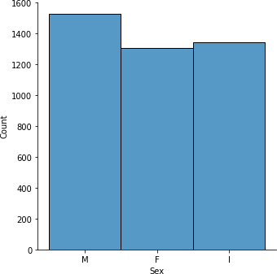

df['Sex'].value_counts().plot(kind='pie',autopct='%.0f')

<matplotlib.axes._subplots.AxesSubplot at 0x7f95f32cd190>

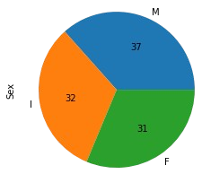

# Bi-Variate Analysis

sns.lineplot(x=df['Whole weight'],y=df['Shell weight'],color='blue')

<matplotlib.axes._subplots.AxesSubplot at 0x7f95f31bfa10>

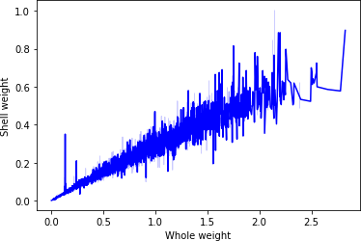

# Multi-Variate Analysis

sns.lineplot(x='Length',y='Rings',data=df,palette='bright',hue='Sex');

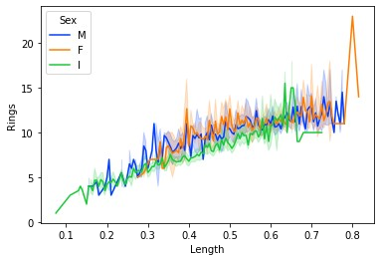

# Perform descriptive statistics on the dataset

df.sum()

|  |  |
| --- | --- |
| Sex | MMFMIIFFMFFMMFFMIFMMMIFFFFFMMMMFMFFMFFFMFFIIII... |
| Length | 2188.715 |
| Diameter | 1703.72 |
| Height | 582.76 |
| Whole weight | 3461.656 |
| Shucked weight | 1501.078 |
| Viscera weight | 754.3395 |
| Shell weight | 997.5965 |
| Rings  dtype: object | 41493 |
| df.mean() |  |
| Length | 0.523992 |
| Diameter | 0.407881 |
| Height | 0.139516 |
| Whole weight | 0.828742 |
| Shucked weight | 0.359367 |
| Viscera weight | 0.180594 |
| Shell weight | 0.238831 |
| Rings  dtype: float64 | 9.933684 |
| df.median() |  |

Length 0.5450

Diameter 0.4250

Height 0.1400

Whole weight 0.7995

Shucked weight 0.3360

Viscera weight 0.1710

Shell weight 0.2340

Rings 9.0000

dtype: float64 df.mode()

Sex Length Diameter Height Whole weight Shucked weight \ 0 M 0.550 0.45 0.15 0.2225 0.175

1 NaN 0.625 NaN NaN NaN NaN

Viscera weight Shell weight Rings 0 0.1715 0.275 9.0

1 NaN NaN NaN

|  |  |
| --- | --- |
| df.std() |  |
| Length | 0.120093 |
| Diameter | 0.099240 |
| Height | 0.041827 |
| Whole weight | 0.490389 |
| Shucked weight | 0.221963 |
| Viscera weight | 0.109614 |
| Shell weight | 0.139203 |
| Rings  dtype: float64 | 3.224169 |
| df.min() |  |
| Sex | F |
| Length | 0.075 |
| Diameter | 0.055 |
| Height | 0.0 |
| Whole weight | 0.002 |
| Shucked weight | 0.001 |
| Viscera weight | 0.0005 |
| Shell weight | 0.0015 |
| Rings  dtype: object | 1 |
| df.max() |  |
| Sex | M |
| Length | 0.815 |
| Diameter | 0.65 |
| Height | 1.13 |
| Whole weight | 2.8255 |

|  |  |
| --- | --- |
| Shucked weight | 1.488 |
| Viscera weight | 0.76 |
| Shell weight | 1.005 |
| Rings  dtype: object | 29 |
| df.count() |  |
| Sex | 4177 |
| Length | 4177 |
| Diameter | 4177 |
| Height | 4177 |
| Whole weight | 4177 |
| Shucked weight | 4177 |
| Viscera weight | 4177 |
| Shell weight | 4177 |
| Rings  dtype: int64 | 4177 |

# Check for Missing values and deal with them

df.isnull().sum() Sex 0

Length 0

Diameter 0

Height 0

Whole weight 0

Shucked weight 0

Viscera weight 0

Shell weight 0

Rings 0

dtype: int64

# Find the outliers and replace them outliers

qnt = df.quantile(q = (0.25,0.75)) iqr = qnt.loc[0.75] - qnt.loc[0.25]

iqr

|  |  |
| --- | --- |
| Length | 0.1650 |
| Diameter | 0.1300 |
| Height | 0.0500 |
| Whole weight | 0.7115 |
| Shucked weight | 0.3160 |
| Viscera weight | 0.1595 |
| Shell weight | 0.1990 |
| Rings | 3.0000 |
| dtype: float64 |  |

lower = qnt.loc[0.25] - 1.5*iqr upper = qnt.loc[0.75] + 1.5 * iqr

lower

|  |  |
| --- | --- |
| Length | 0.20250 |
| Diameter | 0.15500 |
| Height | 0.04000 |
| Whole weight | -0.62575 |
| Shucked weight | -0.28800 |
| Viscera weight | -0.14575 |
| Shell weight | -0.16850 |
| Rings  dtype: float64 | 3.50000 |
| upper |  |
| Length | 0.86250 |
| Diameter | 0.67500 |
| Height | 0.24000 |
| Whole weight | 2.22025 |
| Shucked weight | 0.97600 |
| Viscera weight | 0.49225 |
| Shell weight | 0.62750 |
| Rings  dtype: float64 | 15.50000 |

sns.boxplot(df["Diameter"])

<matplotlib.axes._subplots.AxesSubplot at 0x7f95f2e7fed0>

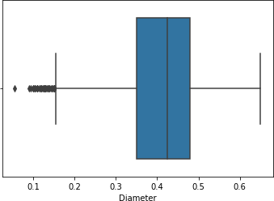

sns.boxplot(df["Height"])

<matplotlib.axes._subplots.AxesSubplot at 0x7f95f30f2a10>

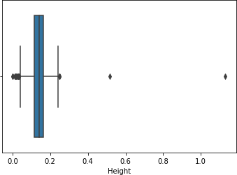

# Check for Categorical columns and perform encoding

df.dtypes

Sex object

Length float64

Diameter float64

Height float64

Whole weight float64 Shucked weight float64 Viscera weight float64 Shell weight float64 Rings int64

dtype: object df["Sex"].replace({"F":0,"M":1,"I":2},inplace = True) df.head()

Sex Length Diameter Height Whole weight Shucked weight \ 0 1 0.455 0.365 0.095 0.5140 0.2245

1 1 0.350 0.265 0.090 0.2255 0.0995

2 0 0.530 0.420 0.135 0.6770 0.2565

3 1 0.440 0.365 0.125 0.5160 0.2155

4 2 0.330 0.255 0.080 0.2050 0.0895

Viscera weight Shell weight Rings 0 0.1010 0.150 15

1 0.0485 0.070 7

2 0.1415 0.210 9

3 0.1140 0.155 10

4 0.0395 0.055 7

# Split the data into dependent and independent variables

x= df.iloc[:,:-1].values y= df.iloc[:,3].values

x array([[1.

|  |  |  |  |  |  |  |  |  |  |
| --- | --- | --- | --- | --- | --- | --- | --- | --- | --- |
| , | 0.455 | , | 0.365 | , | ..., | 0.2245, | 0.101 , | 0.15 | ], |
| , | 0.35 | , | 0.265 | , | ..., | 0.0995, | 0.0485, | 0.07 | ], |
| , | 0.53 | , | 0.42 | , | ..., | 0.2565, | 0.1415, | 0.21 | ], |
| , | 0.6 | , | 0.475 | , | ..., | 0.5255, | 0.2875, | 0.308 | ], |
| , | 0.625 | , | 0.485 | , | ..., | 0.531 , | 0.261 , | 0.296 | ], |
| , | 0.71 | , | 0.555 | , | ..., | 0.9455, | 0.3765, | 0.495 | ]]) |

[1.

[0.

..., [1.

[0.

[1.

y

array([0.095, 0.09 , 0.135, ..., 0.205, 0.15 , 0.195])

# Scale the independent variables

from sklearn.preprocessing import StandardScaler rings = df[["Rings","Diameter"]]

scaler = StandardScaler() scaler.fit(rings)

StandardScaler()

# Split the data into training and testing

from sklearn.datasets import make_blobs

from sklearn.model_selection import train_test_split x, y = make_blobs(n_samples=100)

x_train, x_test, y_train, y_test = train_test_split(x, y, test_size=0.5)

print(x_train.shape, x_test.shape, y_train.shape, y_test.shape) (500, 2) (500, 2) (500,) (500,)

# Build the Model

from sklearn.neighbors import KNeighborsClassifier knn = KNeighborsClassifier(n_neighbors= 3)

knn.fit(x_train,y_train) KNeighborsClassifier(n_neighbors=3) a = knn.predict(x_test)

a

array([2, 0, 0, 2, 2, 1, 1, 2, 0, 1, 1, 0, 0, 0, 0, 1, 0, 2, 2, 1, 1,

2,

0, 2, 0, 0, 2, 1, 1, 2, 0, 1, 2, 0, 1, 2, 1, 1, 2, 2, 2, 1, 2,

1,

1, 1, 1, 2, 2, 2, 0, 1, 1, 1, 0, 2, 2, 1, 2, 0, 1, 1, 1, 1, 0,

1,

2, 1, 2, 2, 2, 2, 1, 0, 0, 0, 0, 2, 2, 1, 2, 1, 0, 0, 2, 0, 0,

1,

2, 1, 2, 0, 2, 2, 1, 0, 2, 0, 2, 1, 0, 1, 1, 1, 0, 0, 0, 1, 0,

2,

2, 1, 0, 0, 1, 2, 0, 1, 2, 1, 0, 0, 2, 0, 0, 2, 1, 2, 2, 2, 0,

0,

2, 1, 1, 2, 1, 2, 1, 0, 2, 2, 2, 0, 2, 0, 1, 0, 1, 2, 2, 2, 2,

0,

2, 1, 0, 2, 2, 0, 2, 1, 2, 1, 0, 0, 0, 0, 1, 0, 0, 0, 2, 1, 0,

0,

2, 0, 2, 2, 2, 2, 2, 1, 2, 0, 2, 2, 2, 0, 0, 0, 2, 0, 2, 0, 2,

1,

2, 1, 2, 0, 1, 0, 1, 0, 1, 2, 1, 2, 2, 2, 1, 0, 1, 0, 2, 0, 0,

1,

1, 0, 2, 2, 1, 1, 1, 2, 0, 1, 1, 2, 1, 2, 2, 1, 2, 2, 1, 1, 0,

1,

0, 0, 1, 0, 1, 2, 1, 1, 1, 1, 2, 0, 2, 2, 1, 0, 0, 1, 0, 2, 0,

1,

0, 2, 1, 1, 0, 0, 0, 2, 1, 1, 2, 1, 2, 1, 1, 2, 1, 1, 1, 2, 0,

2,

0, 2, 0, 2, 2, 1, 2, 2, 0, 2, 1, 1, 2, 0, 1, 0, 0, 1, 1, 1, 0,

0,

2, 1, 0, 0, 1, 2, 0, 2, 0, 1, 0, 1, 0, 2, 0, 0, 2, 1, 2, 2, 0,

1,

0, 0, 0, 1, 1, 2, 1, 1, 2, 2, 2, 2, 2, 0, 1, 0, 0, 2, 2, 1, 0,

2,

0, 1, 0, 0, 0, 0, 2, 0, 1, 0, 1, 1, 0, 1, 2, 0, 2, 0, 2, 0, 0,

2,

2, 0, 2, 0, 1, 0, 2, 1, 1, 1, 2, 1, 0, 0, 0, 0, 0, 2, 1, 2, 0,

2,

2, 1, 2, 0, 1, 0, 0, 0, 1, 1, 2, 1, 1, 2, 1, 0, 2, 0, 2, 0, 2,

1,

2, 2, 0, 0, 0, 2, 1, 1, 0, 0, 0, 1, 0, 1, 2, 2, 0, 1, 1, 0, 2,

1,

2, 0, 2, 1, 0, 1, 2, 1, 0, 2, 2, 0, 2, 2, 0, 0, 2, 0, 0, 0, 1,

0,

0, 2, 1, 1, 2, 2, 1, 0, 1, 1, 2, 0, 1, 1, 1, 2, 2, 2, 2, 1, 0,

1,

2, 0, 1, 0, 0, 0, 0, 1, 1, 1, 0, 0, 0, 0, 2, 0])

from sklearn.metrics import accuracy_score,confusion_matrix print("Accuracy score",accuracy_score(y_test,a))

Accuracy score 0.984 confusion_matrix(y_test,a)

array([[167, 0, 2],

[ 0, 158, 0],

[ 6, 0, 167]])